Declarative Pipeline

Using Declarative Pipeline to launch EC2.

Prerequisites:
Jenkins is installed and running. (Already available):
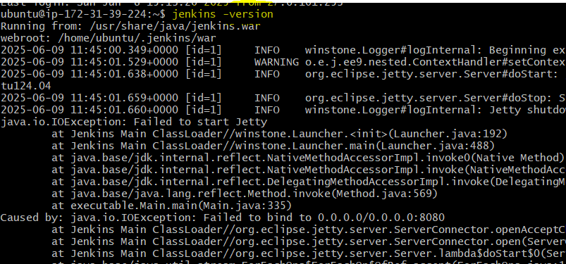
Terraform is installed. (Need to be installed):
sudo apt update && sudo apt upgrade -y
Updates package lists and upgrades existing packages to avoid compatibility issues.
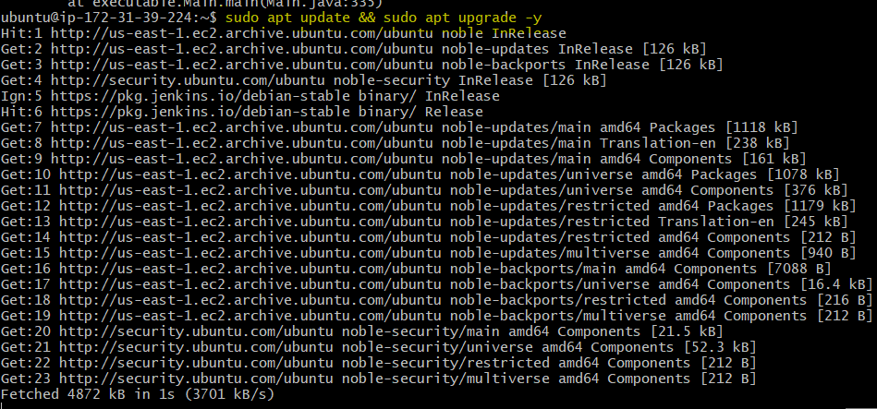

sudo apt install -y gnupg software-properties-common curl
Installs required tools for adding secure external repositories and downloading keys.
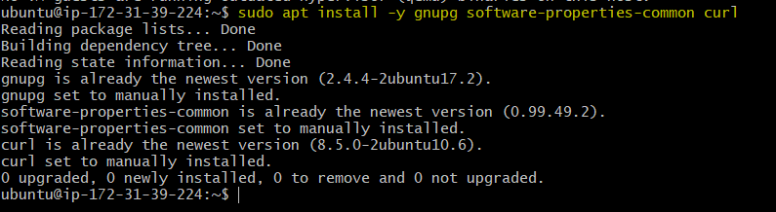

curl -fsSL https://apt.releases.hashicorp.com/gpg | sudo gpg --dearmor -o /usr/share/keyrings/hashicorp-archive-keyring.gpg
Adds HashiCorp's GPG key securely to verify Terraform package authenticity.

echo "deb [signed-by=/usr/share/keyrings/hashicorp-archive-keyring.gpg] https://apt.releases.hashicorp.com $(lsb_release -cs) main" | \
sudo tee /etc/apt/sources.list.d/hashicorp.list
Adds HashiCorp's official repository to your APT sources list for Terraform packages.

sudo apt update
Refreshes package list to include new HashiCorp repository.
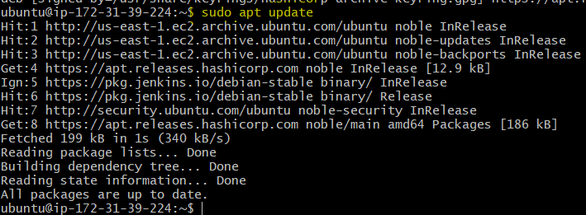

sudo apt install terraform -y
Installs the latest Terraform CLI from HashiCorp's official repository.
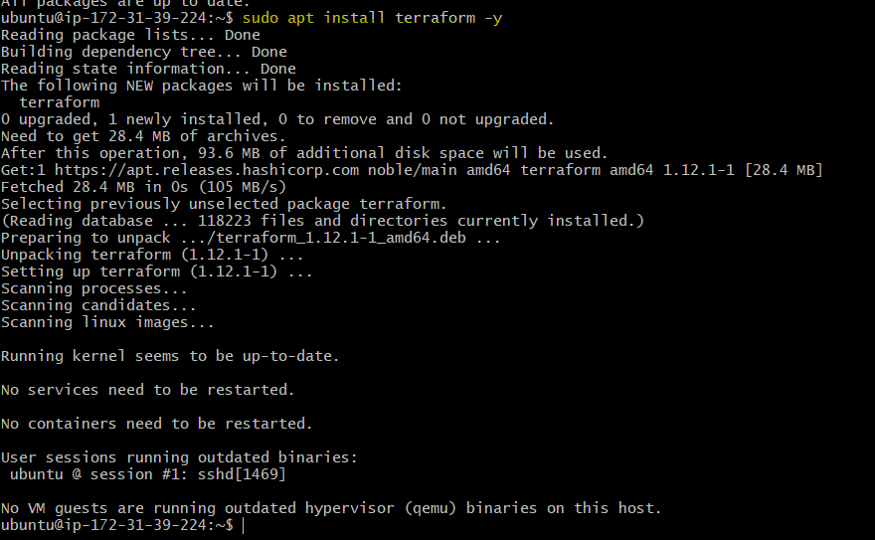

terraform -v
Verifies that Terraform was installed successfully and displays the version.
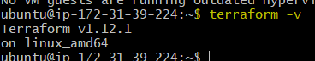

A Git repository contains your Terraform code:
Create a Git repo with a file called main.tf and Jenkins file.
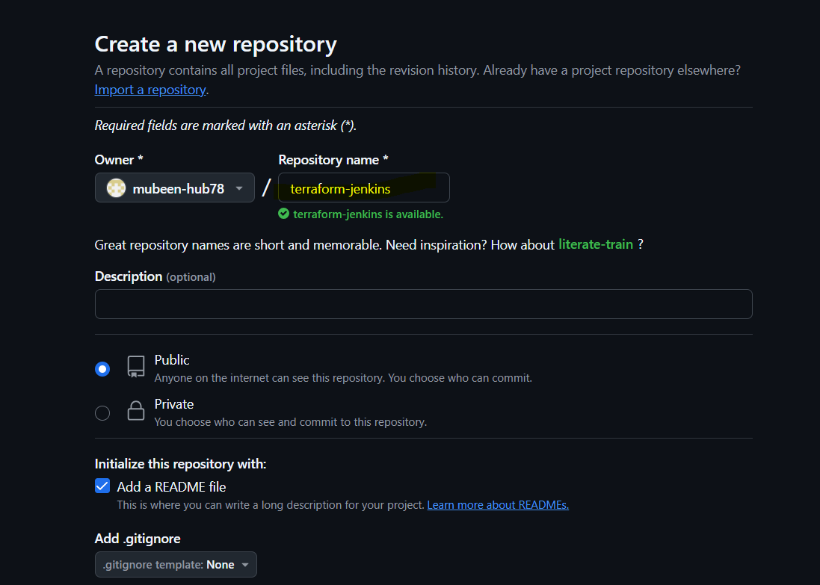
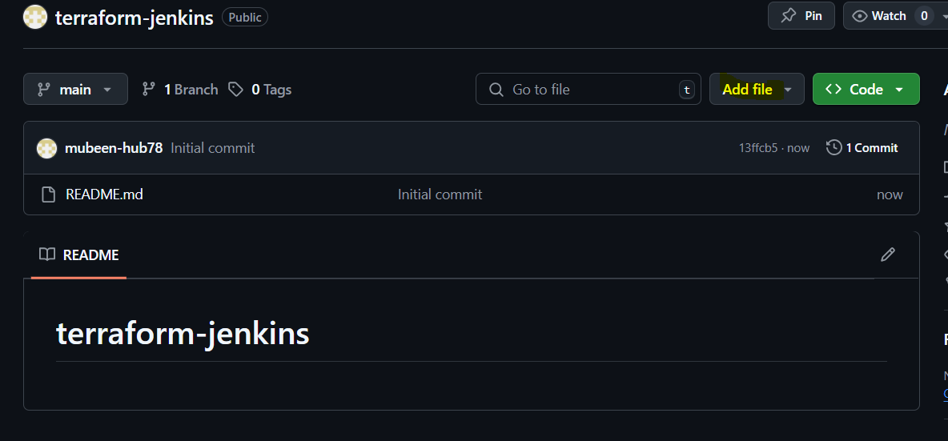
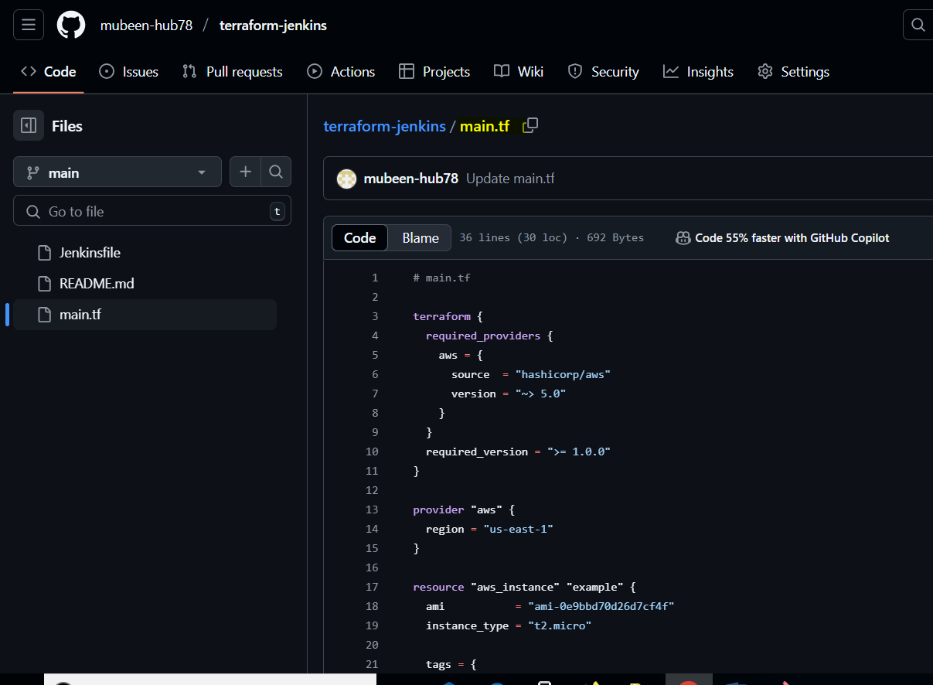
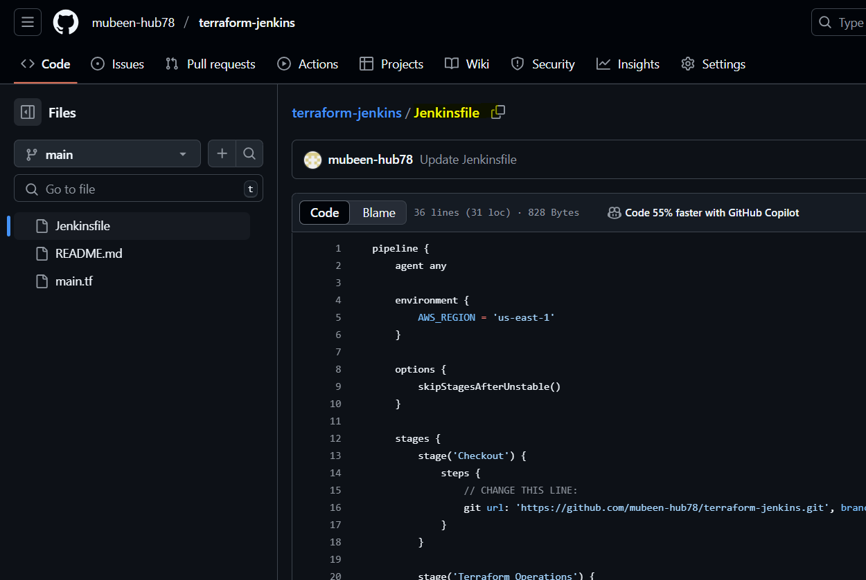

AWS CLI credentials are set up using credentials in Jenkins:
Add Aws credentials plugin in Jenkins.
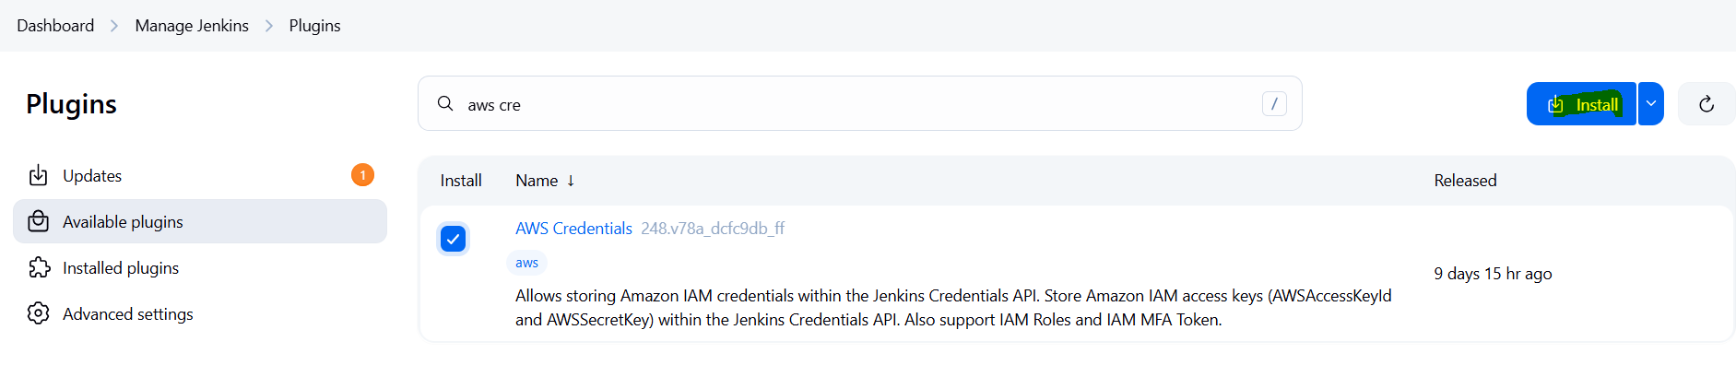

Create Aws credentials with the user having Full EC2 Access.
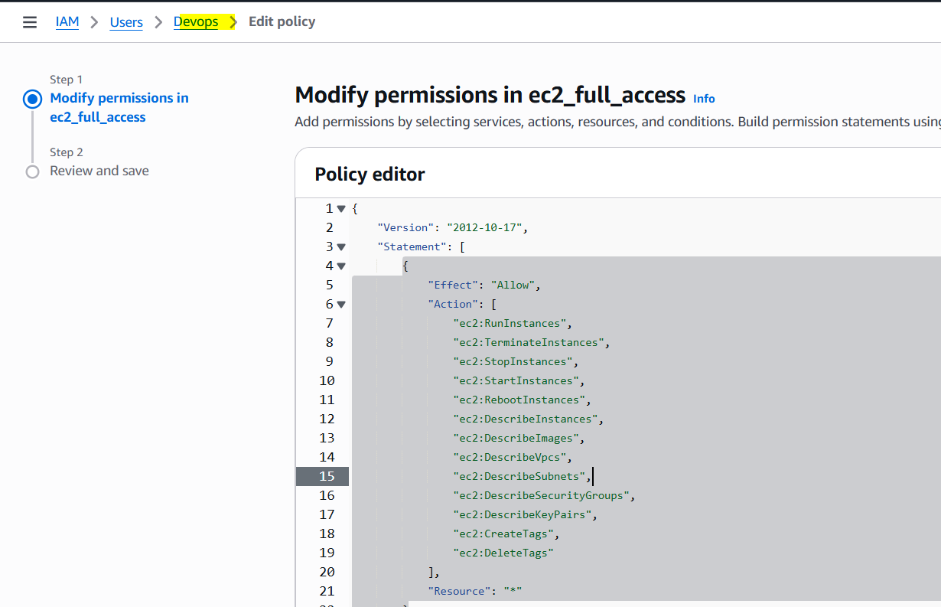
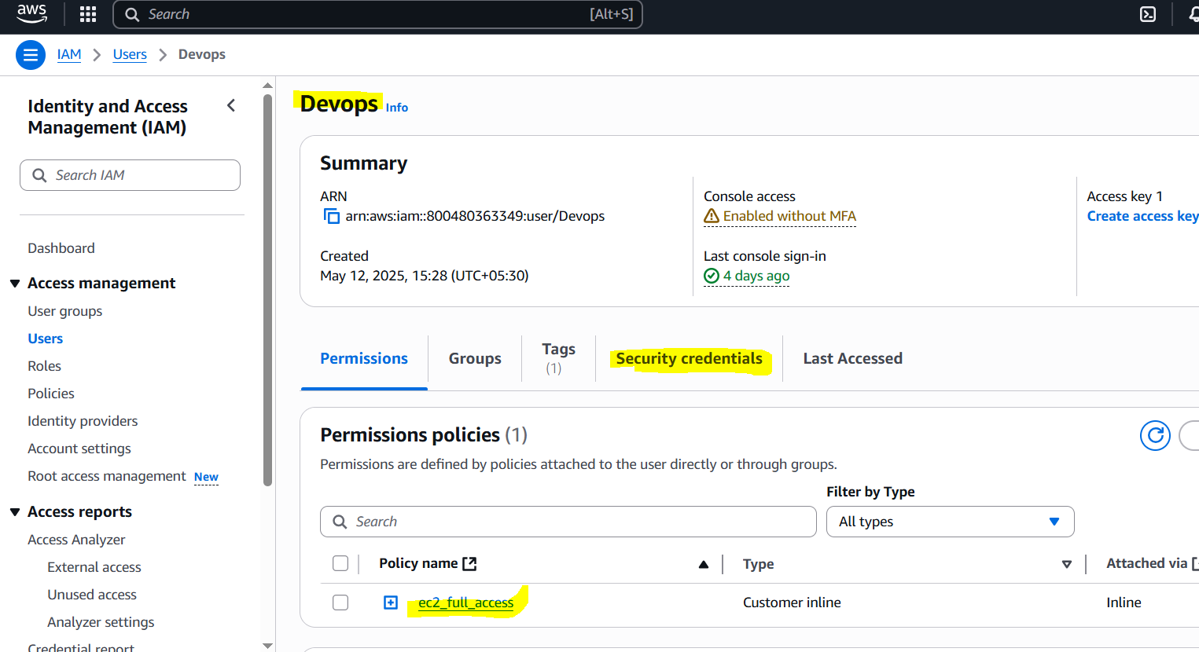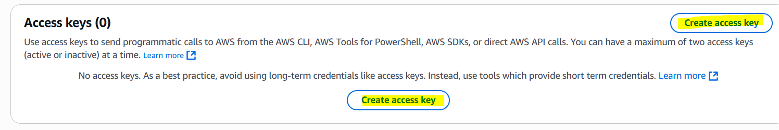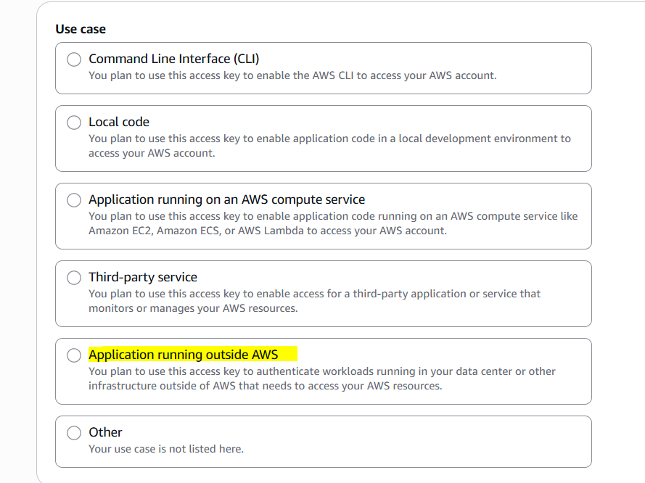
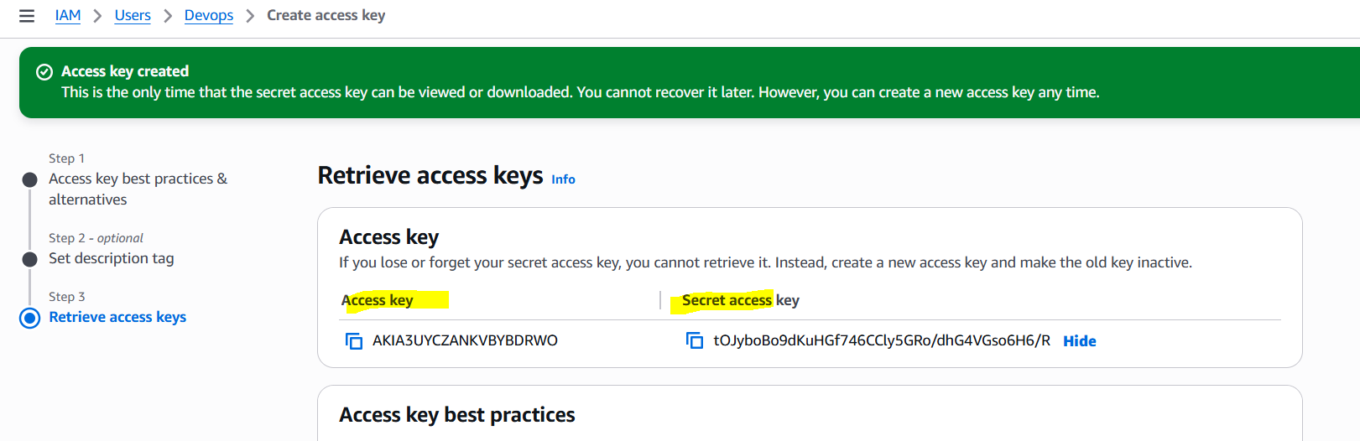

Now we have to add these keys in Credentials of Jenkins.
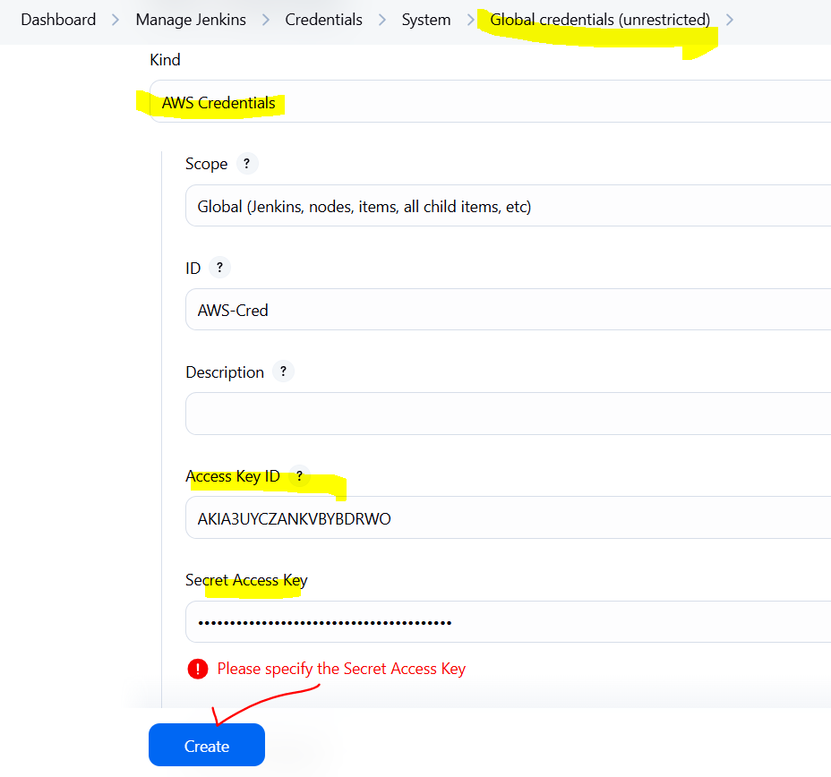

Create a Job for terraform.
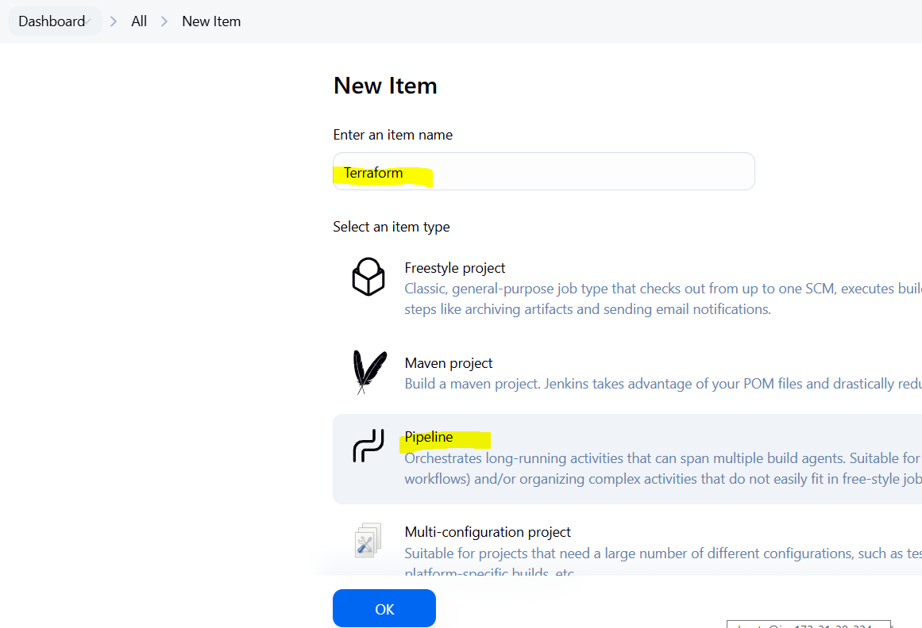
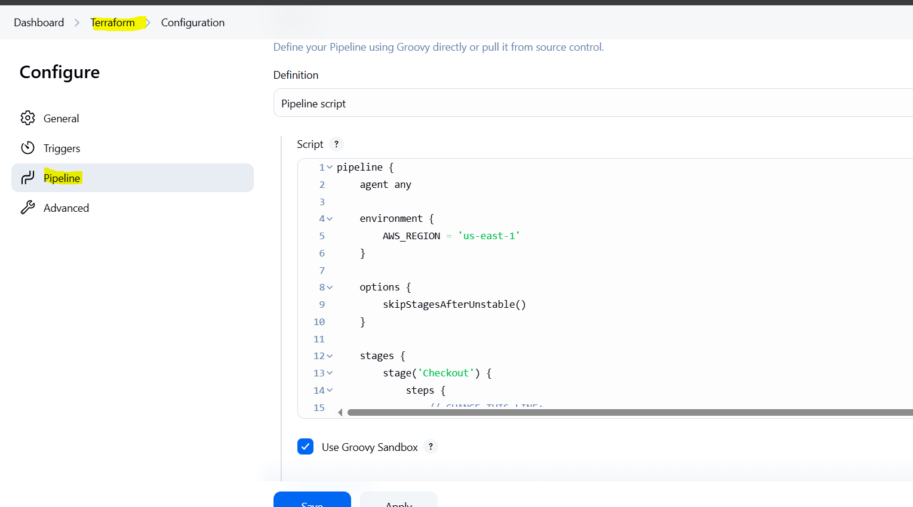

Add this pipeline.

pipeline {
agent any

environment {
AWS_REGION = 'us-east-1'
}

options {
skipStagesAfterUnstable()
}

stages {
stage('Checkout') {
steps {
// CHANGE THIS LINE:
git url: 'https://github.com/mubeen-hub78/terraform-jenkins.git', branch: 'main' // Assuming 'main' branch
}
}

stage('Terraform Operations') {
steps {
withCredentials([[$class: 'AmazonWebServicesCredentialsBinding', credentialsId: 'AWS-Cred']]) {
sh 'terraform init'
sh 'terraform plan -out=tfplan'
sh 'terraform apply -auto-approve tfplan'
}
}
}
}

post {
always {
cleanWs()
}
}
}

Explanation how pipeline works:

Step 1: Start the Pipeline
Jenkins starts the pipeline and chooses an available build machine.
It sets the AWS region as us-east-1.
A temporary workspace folder is created to run the job.

Step 2: Checkout the Code
Jenkins pulls your code from GitHub (like main.tf and Jenkinsfile) into the workspace.

Step 3: Run Terraform Commands
Jenkins securely loads your AWS credentials.
It runs terraform init to set up Terraform and download plugins.
It runs terraform plan to check what will be created on AWS.
It runs terraform apply to create the actual resources like an EC2 instance.

Step 4: Cleanup
Jenkins deletes the workspace folder after the job to save space.

Step 5: Finish the Pipeline
Jenkins shows if the job succeeded or failed based on the commands.

Explanation of how Pipeline is written:

1. pipeline {} → Main Block
All Jenkins Declarative Pipelines start with the pipeline {} block. It defines the structure and all logic inside it.
pipeline {
...
}

2. agent any → Executor Selection
This tells Jenkins to run this pipeline on any available Jenkins agent (node). You can specify a specific label too if needed.
agent any

3. environment {} → Set Environment Variables
You can define variables globally for all stages. Here, we set AWS region for Terraform to use.
environment {
AWS_REGION = 'us-east-1'
}
You can also use credentials here using credentials() helper function if needed.

4. options {} → Job Execution Options
You can customize Jenkins behavior using options. Here:
options {
skipStagesAfterUnstable()
}
- If a stage becomes unstable (for example, test fails), Jenkins will skip the remaining stages.

5. stages {} → Define Stages
All work is divided into stages.

Stage 1: Checkout Code from GitHub
stage('Checkout') {
steps {
git url: 'https://github.com/mubeen-hub78/terraform-jenkins.git', branch: 'main'
}
}
- This stage uses Jenkins’ Git plugin to clone the repo
- Replace the Git URL with your actual repo
- Can use credentials here too if private repo

Stage 2: Terraform Execution
stage('Terraform Operations') {
steps {
withCredentials([[$class: 'AmazonWebServicesCredentialsBinding', credentialsId: 'AWS-Cred']]) {
sh 'terraform init'
sh 'terraform plan -out=tfplan'
sh 'terraform apply -auto-approve tfplan'
}
}
}

Breakdown:
- withCredentials:
  - Binds the AWS credentials securely to environment variables
  - AWS-Cred is the ID of the stored credentials (configured under Jenkins > Credentials)
- terraform init:
  - Initializes the working directory and downloads required providers
- terraform plan -out=tfplan:
  - Checks what changes Terraform will make and saves to a plan file
- terraform apply -auto-approve tfplan:
  - Applies the infrastructure changes automatically using that plan
  - No manual confirmation required due to -auto-approve

6. post {} → After Job is Done
This block defines what should happen after pipeline completes.
post {
always {
cleanWs()
}
}
- always → Executes regardless of success or failure
- cleanWs() → Cleans the Jenkins workspace (deletes all files/folders)

Run the job.
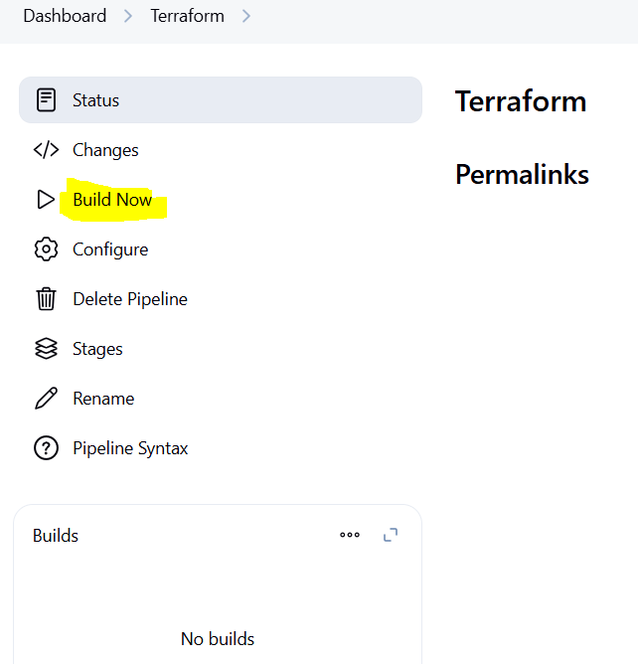
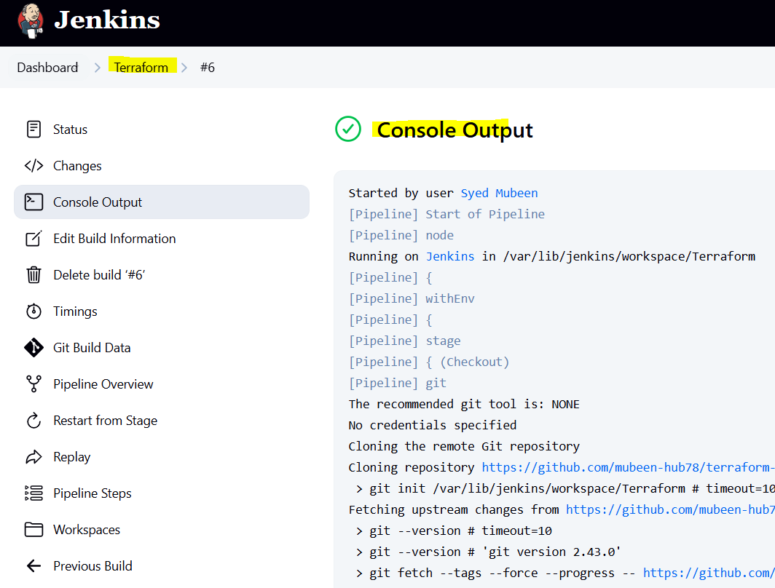
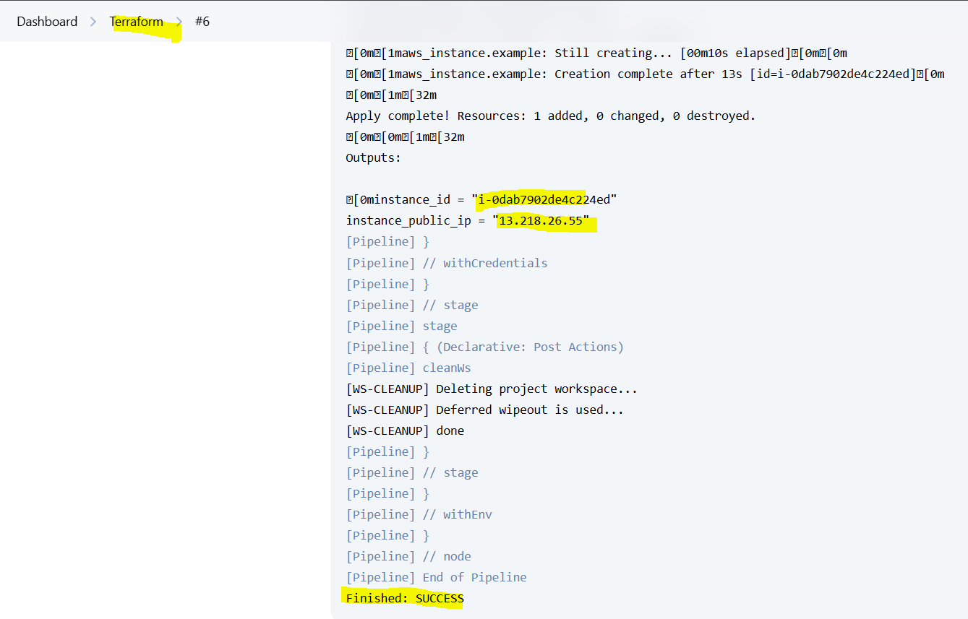
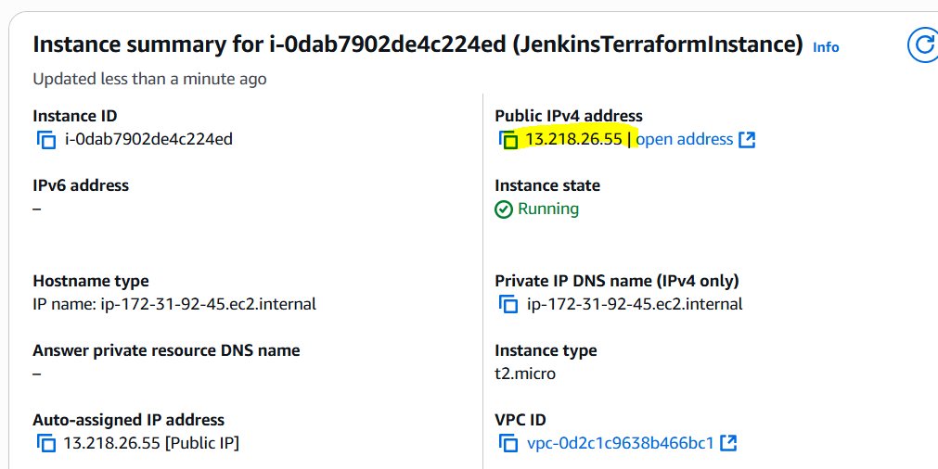

Instances are created Successfully.

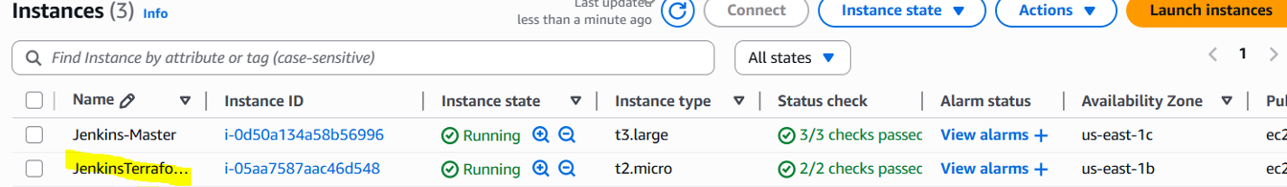

THE-END

